UNIT 16 EXERCISES

1) A uniform solid cylinder and a uniform cylindrical shell are placed side by side at the top of an incline of height h as in the picture below.

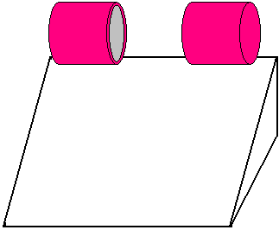

If they are released from rest and roll without slipping,

(i) determine their speeds when they reach the bottom. Show your work.

(ii) Which object reached the bottom first? Explain your reasoning.

2) A playground merry-go-round of radius R = 2.00m had a moment of inertia of I = 250kg/m² and is rotating at 10.0rev/min about a frictionless vertical axle. Facing the axle, a 25.0kg child hops onto the merry-go-round and manages to sit down on its edge. What is the new angular speed of the merry-go-round? Show your work.

3) A spool of wire of mass M and radius R is unwound under a constant force F as in the diagram below. Assuming that the spool is a uniform solid cylinder that does not slip,

(i) show that the acceleration of the center of mass is

(ii) and that the friction is to the right and is equal in magnitude to . Show your work.

