UNIT 12 EXERCISES

1) A pulse of the shape shown below propagates to the right along a string with velocity v.

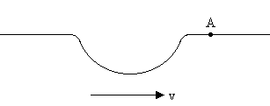

Describe in detail the motion of particle A on the string as the pulse goes by. Be sure to indicate

(i) the direction in which A is moving at various points along the pulse

(ii) and whether the velocity of A is increasing, decreasing or zero at these various points.

2) Ultrasound has a speed of 1500m/s in tissue.

(i) Calculate the smallest detail visible with 2.0MHz ultrasound. Show your work.

(ii) How long does it take the echo to return to the probe from a depth of 0.10m? Show your work.

3) The diagram below shows two pulses on a string at time t = 0.

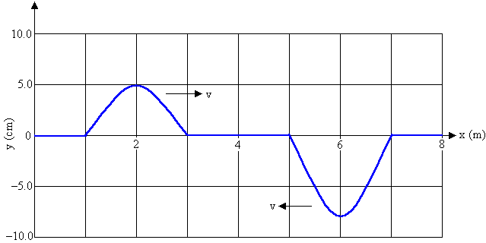

The pulses are moving toward each other, the speed of each pulse is 2.5m/s. Sketch the shape of the string at 0.60, 0.80 and 0.90s.

