UNIT 9 EXERCISES

All of these exercises should be done by using the concepts of work and energy. NOT kinematics.

1) A 150kg block is to be moved from point a to point b in the diagram below.

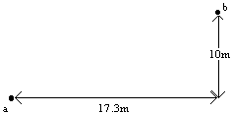

a) Calculate the work done by the gravitational force in each of the cases below:

(i) The block is pushed horizontally 17.3m and then lifted vertically 10m.

(ii) The block is placed on an inclined plane at an angle of 30° to the horizontal (as in the picture below) and pushed up the plane.

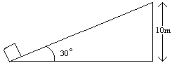

(iii) The block is pushed 8.9m horizontally, then pushed up an inclined plane at an angle of 50° to the horizontal (as in the picture below).

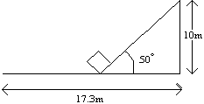

2) A car with a mass of 1000kg is at rest at the base of a hill. It accelerates up the incline reaching a speed of 20m/s at a height of 100m. The work done by the frictional force is 450,000N.

a) Calculate the change in kinetic energy of the car. Show your work.

b) Calculate the work done by the motor of the car. Show your work.

3) At Six Flags over Texas in Arlington the Titan towers 255 feet (77.7m) above the earth, the muscular steel superstructure features one of the world's mightiest drops.

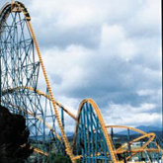
(from the website www.sixflags.com)

From this height what speed can be reached when it reaches the bottom of the first drop? Show your work.

4) Consider the diagram below.

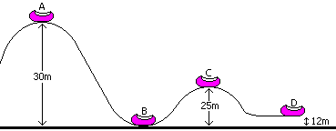

a) The roller coaster is pulled up to point A where it, and its screaming occupants, are released from rest. Assuming no friction, calculate the speed of the coaster at points B, C, and D. Show your work.

b) Now, suppose the roller coaster passes point A with a speed of 1.70m/s. If the work done by friction is 45,000J, with what speed will it reach B? The mass of the coaster is 1000kg. Show your work.

