UNIT 8 EXERCISES

1) Suppose the ski patrol lowers a rescue sled and victim 30m down a slope at a constant speed as shown below. The victim and sled have a total mass of 90kg. The angle of the slope is 60.0º.

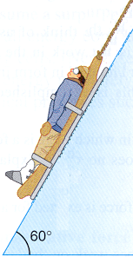
(from College Physics by Paul Peter Urone, Brooks/Cole Publishing Company, NY, 1998

If the coefficient of friction is 0.100

a) find the work done by friction as the sled moves down the hill. Show your work.

b) How much work is done by the rope on the sled? Show your work.

c) What is the work done by gravitation? Show your work.

d) What is the total work done? Show your work.

2) A 50kg crate is pulled 40m along a horizontal floor by a constant force exerted by a person F_{P} = 100N, which acts at a 37º angle as in the picture below.



If the floor exerts a frictional force of 50N, determine the work done by

a) the force of the person pulling.

b) The gravitational force.

c) The normal force.

d) The frictional force

e) Calculate the total work. Show your work.

3) While testing a model canon, a 1.0kg ball is fired straight up into the air. It rises 22.5m and falls back to the height at which it was launched. What is the net amount of work done on the ball by gravitational force?

