UNIT 5 EXERCISES

1) A skier has just begun descending a 30º slope. Assuming the coefficient of kinetic friction is 0.10,

a) draw a force diagram

b) find her acceleration

c) suppose, instead the snow is slushy and she moves down the hill at a constant speed. What will the coefficient of kinetic friction be? Show your work.

2) Determine the net compressive force acting on the patella as a result of the action of the quadriceps muscle (F_{m} upward) and the patellar tendon (F_{t} downward) as shown in the diagram below. Take the angle between the muscle group and the tendon to be 160º, and assume the leg is bent symmetrically so that F_{m} = F_{t} = 100N. Show your work.

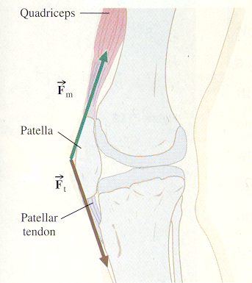
(From Physics: Algebra/Trig Second Edition, Brooks/Cole Publishing Company, 1998.)

3) The diagram below shows two masses free to move, M = 50kg and m = 20kg, connected by a massless cable on two frictionless pulleys.

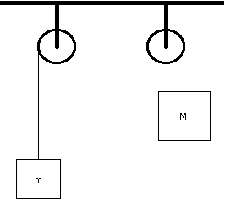

a) Draw a force diagram for each mass.

b) Are the masses accelerating? Compare the acceleration of mass M and mass m. Explain.

c) Find the tensile force in the cable. Show your work.

d) Find the acceleration of each mass. Show your work.

