UNIT 4 EXERCISES

1) Consider an object resting (the object is not moving) on an inclined plane as in the diagram below.

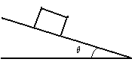

a) If the coefficient of static friction is μ_{s} = 0.35, find the angle at which the block would begin to slide. It is useful to choose the x-axis parallel to the incline plane and the y-axis perpendicular to the incline plane, for this problem. The mass of the block is 10kg. Show your work.

b) What is the frictional force when the incline is 10°? Explain your reasoning.

2) What force is exerted on the tooth in picture below if the tensile force in the wire is 25.0N? Show your work.

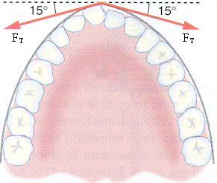
(from College Physics by Paul Peter Urone, Brooks/Cole Publishing Company, NY, 1998

3) A person pushes a 16kg lawn mower at constant speed with a force of 80N directed along the handle, which is at an angle of 45º to the horizontal.

a) Draw a force diagram showing all the forces acting on the mover.

b) Calculate the horizontal forces acting on the mower. Show your work.

c) Calculate the vertical forces acting on the mower. Show your work.

