UNIT 2 EXERCISES

1) If a force of 2.73N is applied in the positive x-direction to a 1kg object and the object accelerates at 1.87m/s² in the positive x-direction, what is the magnitude and direction of the force of friction on the object? Explain your reasoning.

2) At the start of unit 2, you watched a movie clip of a crash test dummy with and without an airbag. The movie clip shows the collision in slow motion. The actual collision took less than a second. For this problem assume the collision took approximately one second. Estimate the amount of time the crash test dummy was in contact with the steering wheel. The initial velocity of the crash test dummy was 35 mph in the forward direction. For this problem, assume that the final velocity (after hitting the steering wheel) is 35 mph in the backward direction. Estimate the acceleration (magnitude and direction) due to the force of the steering wheel (while in contact with the steering wheel) of the crash test dummy and the force (magnitude and direction) of the steering wheel on the crash test dummy. You will have to estimate the mass of the crash test dummy. Show your work. Explain your reasoning.

3) Consider the velocity versus time graph below.

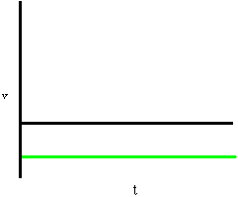

What net force could be applied to produce this type of motion? Explain your reasoning.

4) Consider the acceleration versus time graph below.

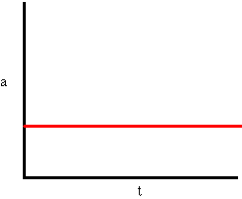
What net force could be applied to produce this type of motion? Explain your reasoning.

