(Excerpt from Department of Physics Newsletter, January, 2002)

Bill Ford Has Successful Career In The Aerospace/Defense Industry

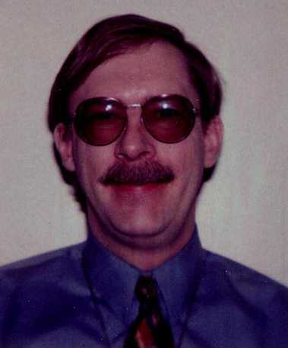
Since completing his PhD in theoretical semiconductor physics, under the direction of Professor Charley Myles, Dr. William C. (Bill) Ford (PhD, 1986) has had a very successful career in the aerospace industry. Dr. Ford is an Analyst for XonTech, Huntsville, AL. He is responsible for performing modeling and analysis for the National Missile Defense Program on the Sensor Simulation Test Bed (SSTB). He is also responsible for modeling the Ground Based Interceptor (GBI) and the Space Based Infrared Satellite (SBIRS) network. He developed both the three-degree-of-freedom GBI flight simulation and the satellite model used in the SSTB.

Dr. Ford has more than 15 years of industrial experience. Before taking his present job in 1998, he worked (1997-98) as a Senior Engineer for CAS, Inc., as a Senior Project Engineer (1996-97) for Boeing/McDonnell Corp., and as a Senior Project Engineer (1986-96) for McDonnell Douglas Corp.. His expertise includes modeling and simulation of sensor systems (infrared, radar, and electro-optical), three-degree-of-freedom flight simulation, operations analysis, survivability and vulnerability analysis, systems engineering, risk management, device physics, orbital mechanics, UNIX administration, and object oriented programming. Some of his accomplishments include creating and integrating Weapon System and SBIRS models into XonTech’s SSTB, acting as Program Manager for the Harpoon/SLAM Survivability Assessment Program, improving McDonnell Douglas’s proprietary radar and force-on-force engagement simulations, acting as Security Advisor to the Harpoon/SLAM Program, and authoring McDonnell Douglas’s Risk Management Process.

At the Editor’s request, Dr. Ford wrote the following, about how he has used his physics education in his industrial career:
“While updating my company biography, it dawned on me how many different areas I’ve worked in over the last 15 years. Immediately after receiving my PhD from TTU, I went to work for McDonnell-Douglas in St. Louis, as a device physicist testing and modeling the performance of infrared detectors. The work was close to my dissertation area of semiconductor physics. I learned that working in industry can be quite volatile, as that program was canceled a few years later. I transferred within the company, and became an operations analyst for the Harpoon antishipping cruise missile program. This meant that I needed to acquire skill in the modeling and simulation of radar, surface to air missile, and weapon system performance; analyzing foreign weapons systems; force-on-force simulations; and survivability and vulnerability analysis. I was expected to get up to speed and make significant contributions IMMEDIATELY! This has been true for all of my jobs! I took continuing ed courses in radar and vulnerability analysis. These, plus on-the-job training and study helped me to be successful in this job.
After the Soviet Union collapsed, the Harpoon program was reduced, so I switched jobs again. My next job was performing Programmatic Risk Management. Again, I took a continuing education course and had some on-the-job mentoring. I worked on the Tomahawk program as part of the Integration Agent contract. As a part of this job, I wrote the corporation’s best practice guide for risk management, which is still in use today.
The Boeing took over McDonnell-Douglas at about this time and I had an opportunity to transfer to the development program of the F/A-18E/F Super Hornet aircraft. My assignment was performing Design to Cost, Life Cycle Cost, and Cost As an Independent Variable analyses. This involved doing studies for new aircraft design on everything from avionics and weapons to landing gear and wing construction to alternative maintenance concepts and logistics over the aircraft life cycle. For this job, I had only on-the-job training. As the program moved toward production, the work slackened, so I moved to another defense contractor, CAS, Inc., where I was systems administrator of a computer network and was involved in the validation and verification of a suite of infrared missile simulations.
Then, I took my current job, which involves modeling and simulation work on the National Missile Defense Program at XonTech, Inc., in Huntsville, AL. I am responsible for modeling all aspects of the Ground Based Interceptor and the SBIRS network. I do flight and orbital dynamics and guidance system and sensor modeling. I had the opportunity to take a continuing education course in guidance and control theory, but have had to learn the rest through self-study.
When I was a student, I never imagined that I’d wind up doing such a broad variety of jobs! I suppose that I am a “Jack of all trades,” but, hopefully, I’m a master of a few! I credit my Physics education at TTU with helping me to be able to “hit the ground running” with each new assignment. In addition to technical and scientific knowledge, the publication and presentation of research results and the writing of a dissertation provided me with valuable experience in technical writing and public speaking. These are the most numerous products of my work. I would like to say ‘Thanks’ to my Professors at TTU for their dedication and excellent teaching and advising. I would also like to encourage current students to get all they can from their courses and research. What you learn will stand you in good stead in the job market, whatever you wind up doing.” (Dr. Ford’s contact info: 218 Beaver Run Drive, Madison, AL 35758. Phone: (256) 971-9871. Email: Bill_Ford@XonTech.com.)

